# Accessing the VM and Deploying the Application

## Tools Used

* Deployment will use the Remote Desktop Connection application provided by the Windows Operating System. Sign in using the credentials given to you by the professor.
* This guide will first show you how to access the VM.
* Scroll down further to see how you can deploy to the VM.

### Credentials for Team BOB (May vary for your team)

* Name of VM: Fall22-4250-1-2
* IP Address: 151.141.91.39
* Username: stuadmin
* Password: tUpme35$
* Note that these credentials may vary for your team.

### The Steps – Accessing the VM

1. Launch the Remote Desktop Connection application on your windows machine. If you just search up “remote” in the search bar, you should see it as:

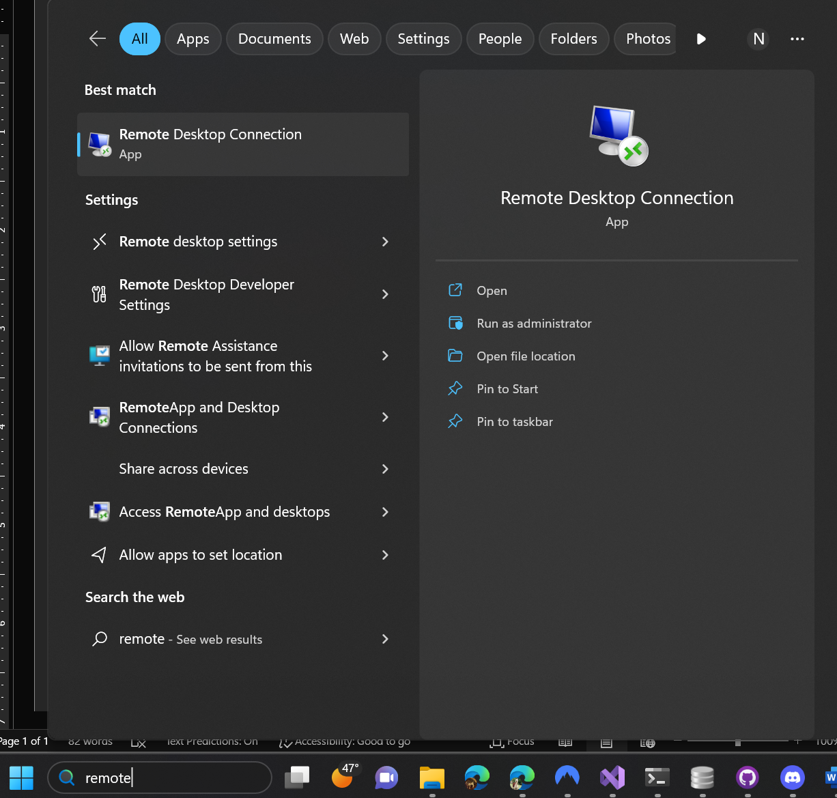

1. Click on that “Remote Desktop Connection” application. You should see this window:

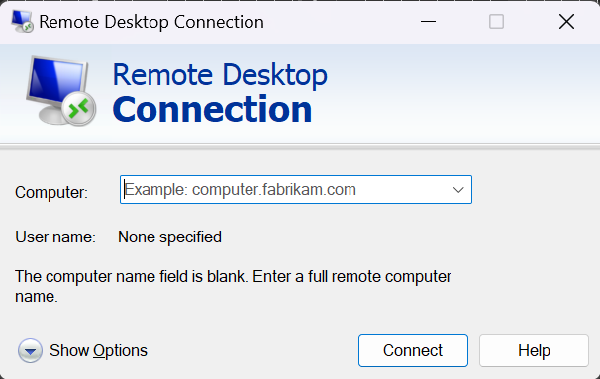

1. Click on Show Options. You get the ability to enter a username alongside the computer.

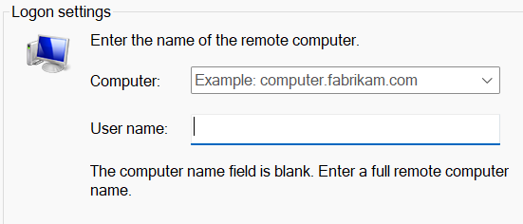

1. Enter in your credentials: IP Address of the VM into the Computer field, and the Username into the Username field. It will look similar to this:

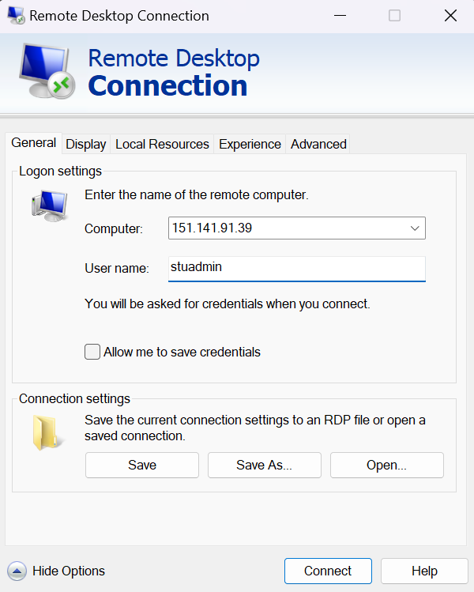

1. Press “Connect”. Then, wait a few seconds for the application to remote connect to the machine.
2. If you get an error screen like this:

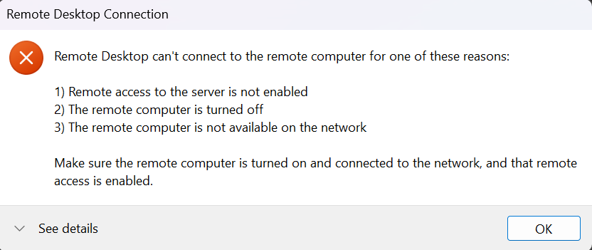

* 1. If you are using a VPN, disconnect from it. Then try to connect to it.
  2. Ensure that you are using the ETSU network. Remote Desktop Connection won’t work on Eduroam or other network.
  3. Ask your instructor. He’ll provide you with the credentials of the person you should email about the VM (We’ll call them the VM Master).
  4. Email the VM Master and include the screenshot of the error in the email. Tell them that you tried to connect to the Fall22-4250-1-2 VM machine with the IP address “151.141.91.39” under the “stuadmin” username and it failed. It did not show the window to input the password for the user. (If your IP address is different, feel free to change it.)

1. Viola! You should see this screen:

(Insert Screen Here)

### The Steps – Deployment Locally

These steps are adapted from Team 1’s documentation on Publishing the project.

1. Open the project solution for this project. Then, on the top-left menu, go to Build > Publish ScavengeRUS.

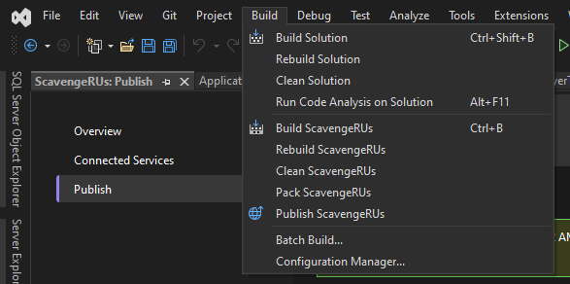



1. Click on Publish ScavengeRUS. Then click on Folder and hit “Next”.

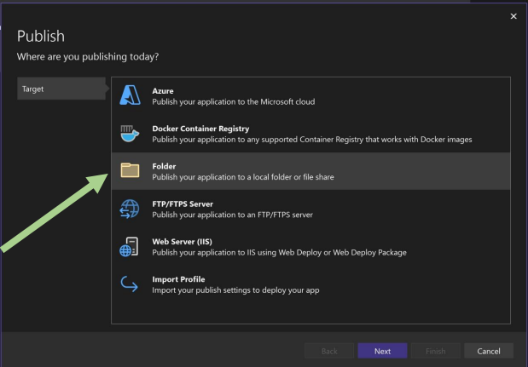

1. The default path should be bin\Release\net6.0\publish\. This path is fine, but you would like to store it elsewhere,

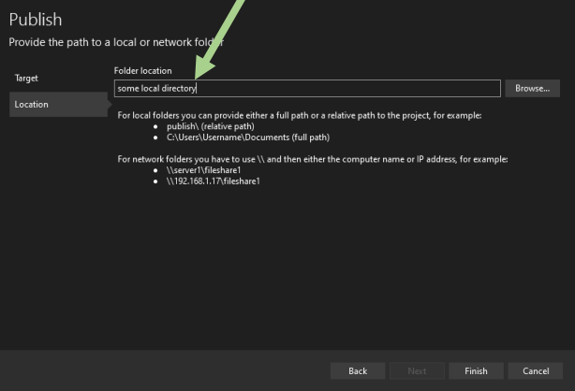

1. Once you hit next, you should see a menu like this. Ignore the “Publish succeeded” message. Don’t worry if the settings are not exactly right – we will change that in the next step.

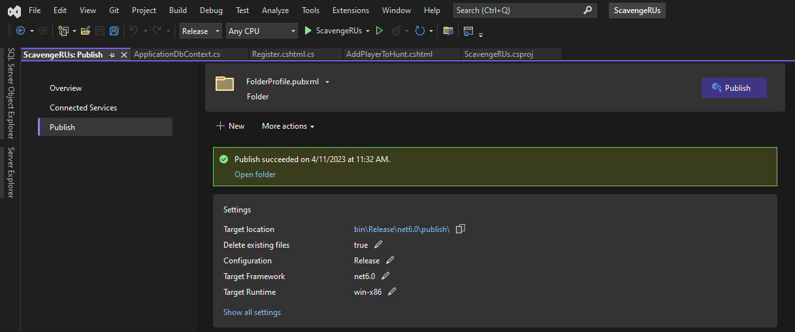

1. Click on More Actions and click the Edit option:

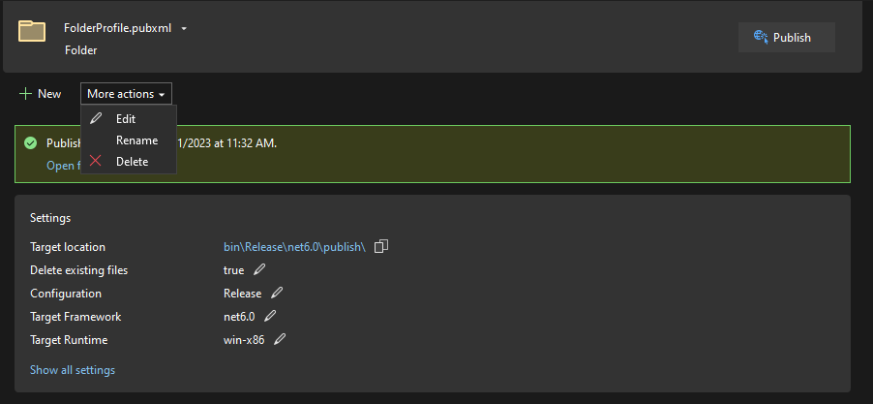



1. Ensure that your settings look like this:

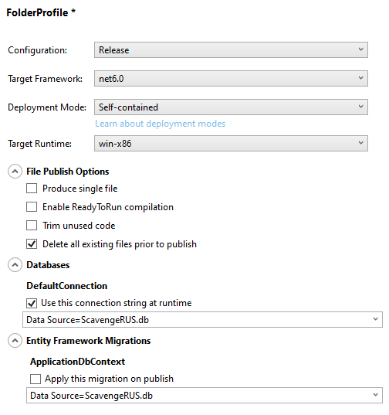

1. Hit Save.

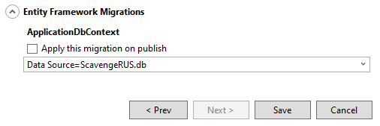



1. Click on the Publish option next to FolderProfile.pubxml.

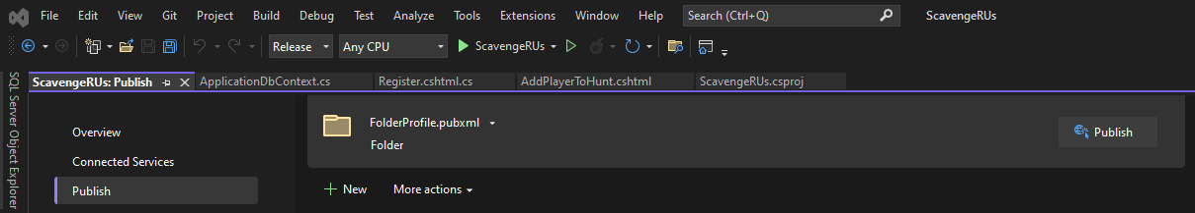



1. Wait a minute for the Compiler to build the published project. If there are any compilation errors, fix them and attempt to publish again.
2. Look at the output of the build:

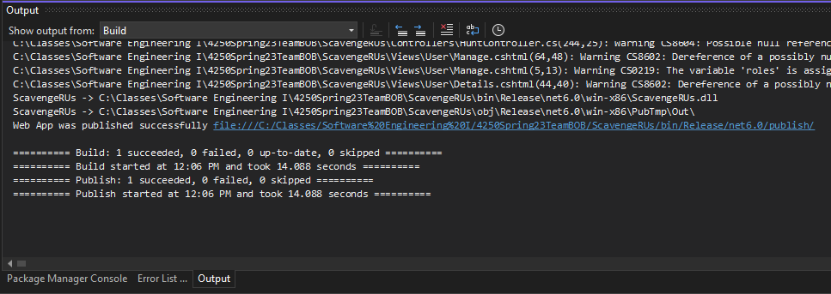



1. CTRL+LeftClick on the link highlighted above. You should be taken to a file menu.

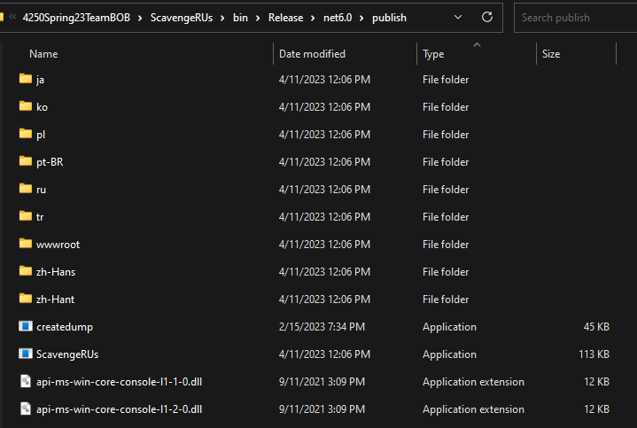



1. Locate and run the ScavengeRUs.exe file.
2. Look for a console window that pops up. You should see something like this after running the application:

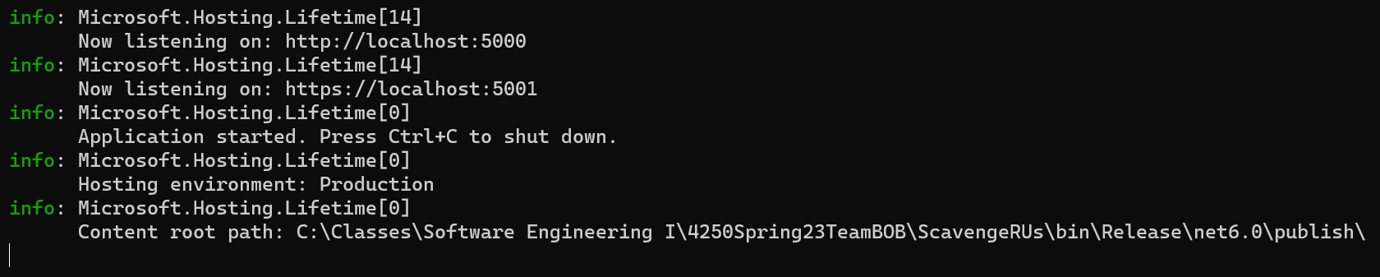



1. CTRL+LeftClick on either option above. You’re taken to the BucHunt landing page!

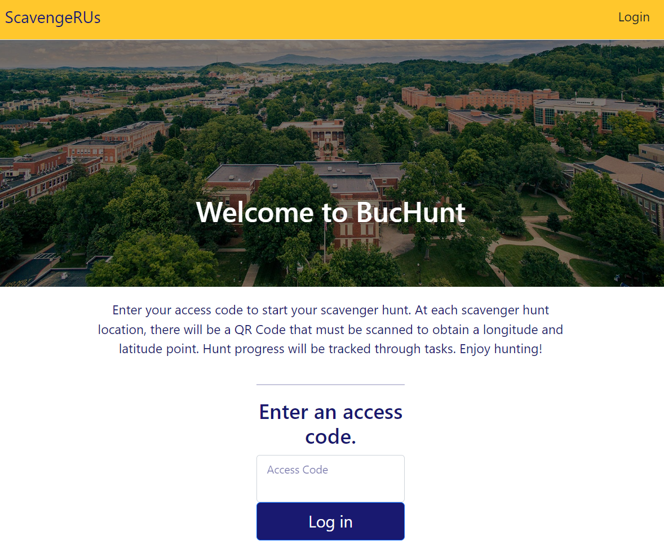

### The Steps – Deployment to the VM

### Deploying to the VM

### Deploying to Microsoft Azure

* Note: To setup a Microsoft Azure account, Microsoft requires your credit card information. Therefore, this step is not recommended. However, it is here as a second option.
* Azure provides a $200 free trial, along with 12 months of free services (or more)
* The person who owns the team’s repository **MUST** be the one to deploy to Microsoft Azure. (Provided you are using GitHub to upload your code.) No one else will be able to deploy.

1. You’ll need a Microsoft Azure account. Go to [Create Your Azure Free Account Today | Microsoft Azure](https://azure.microsoft.com/en-us/free/search/?OCID=AIDcmm5edswduu_SEM__k_f16f1dcf6e2012105fde79f1d3b6e95b_k_&ef_id=_k_f16f1dcf6e2012105fde79f1d3b6e95b_k_) (<https://azure.microsoft.com/en-us/free/search/?OCID=AIDcmm5edswduu_SEM__k_f16f1dcf6e2012105fde79f1d3b6e95b_k_&ef_id=_k_f16f1dcf6e2012105fde79f1d3b6e95b_k_>) to start.
2. Sign in using your ETSU account.
3. When registering, you may use either your personal email address or your ETSU email address.
   1. You’ll need to verify your phone number to complete registration. Be sure that you can access your phone
4. Hit next. Microsoft Azure wants your credit card details.

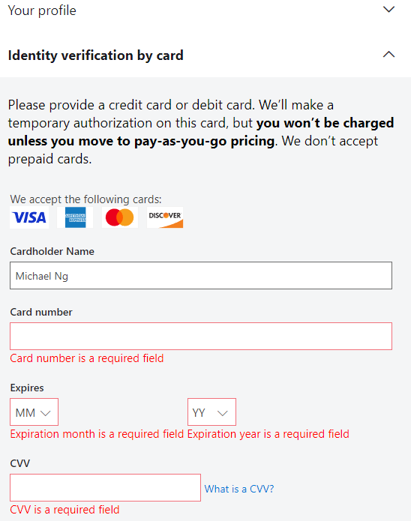

* 1. “Identity Verification by Card”. Thanks, Microsoft. Very Cool. First, **ensure that the connection to the website is secure.**

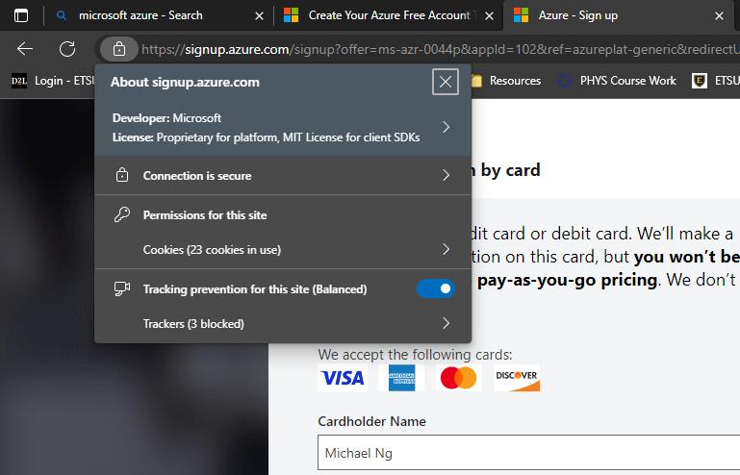



1. Enter your credit card details – or deploy to the VM instead. This step is unavoidable when using Azure. Once you’ve put in your credit card, hit the “sign up” button.
2. You’ll need to wait a minute for Microsoft to set up the account for you. (Actually, it ensures that your credit card is valid. I got a transaction warning on my phone about Microsoft Store during this time).
   1. While you’re waiting, feel free to give the signup experience a bad review. Microsoft might contact you if you decide to do so, so submit the review if you are courageous…
3. 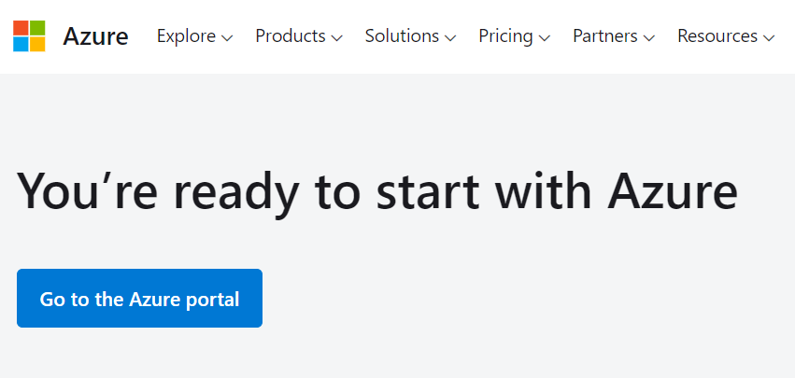
   1. Hit that “Go to the Azure Portal” Button.
4. 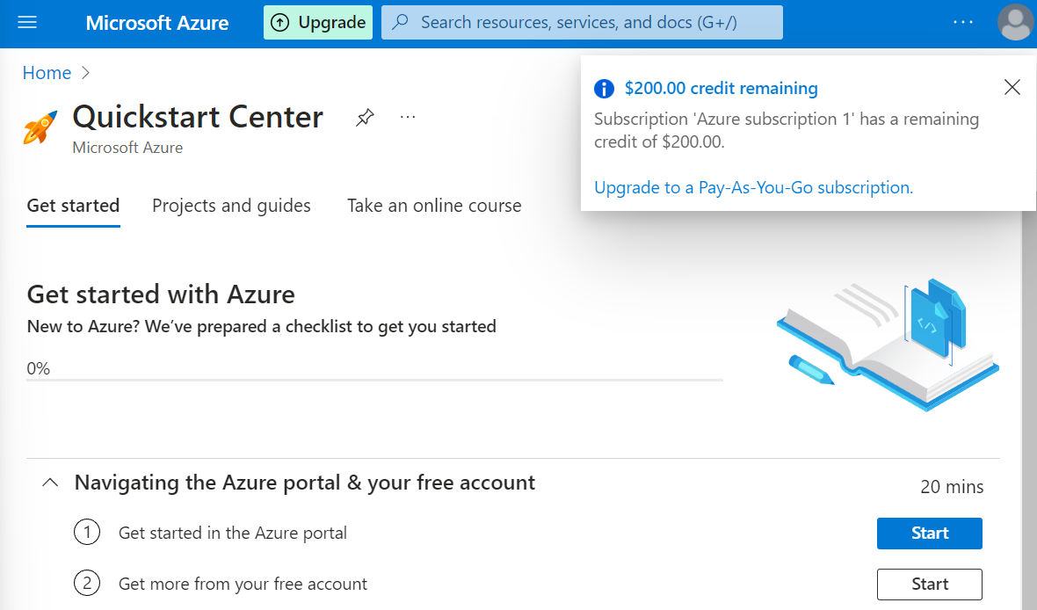



* 1. There are several things to dissect here once you get to this screen.
     1. First, note that you start with $200. As of now, I don’t know how much Microsoft prices the usage on their servers. If it’s anything like AWS, it should be enough for hosting a project of this scale.
     2. There’s a checklist to start off with. We’ll need to familiarize ourselves with Azure before we can move on with the project.

1. Hit the “Start” button next to (1) on Navigating the Azure Portal & your free account (Marked Green above)
2. Watch the tutorial video from Eric Boyd and complete every step (1 – 10). The portal is located at portal.azure.com.
3. Go to App Services

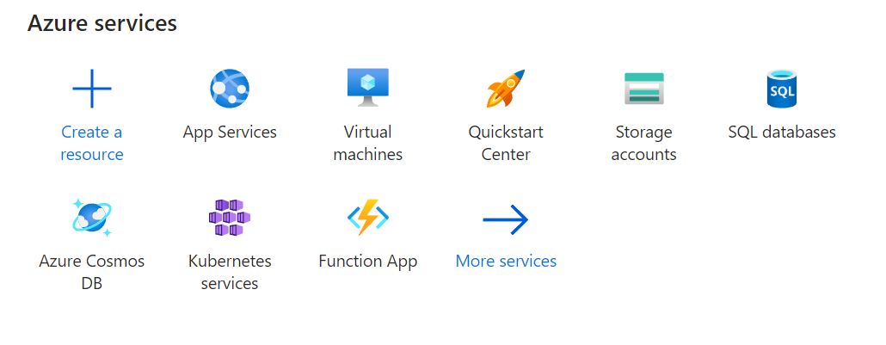



1. Create a New App Service

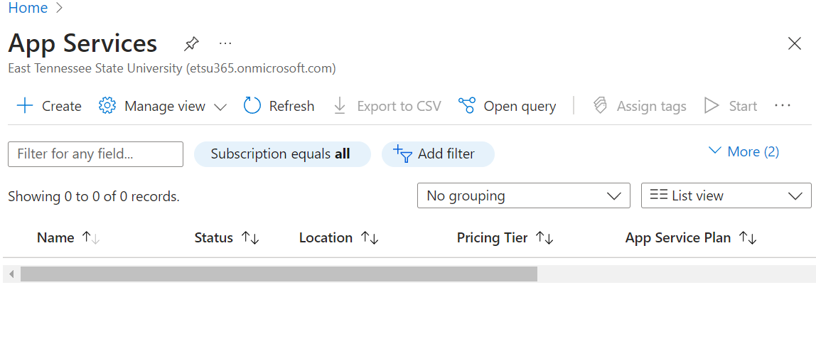



1. Name the Resource Group BucHunt.

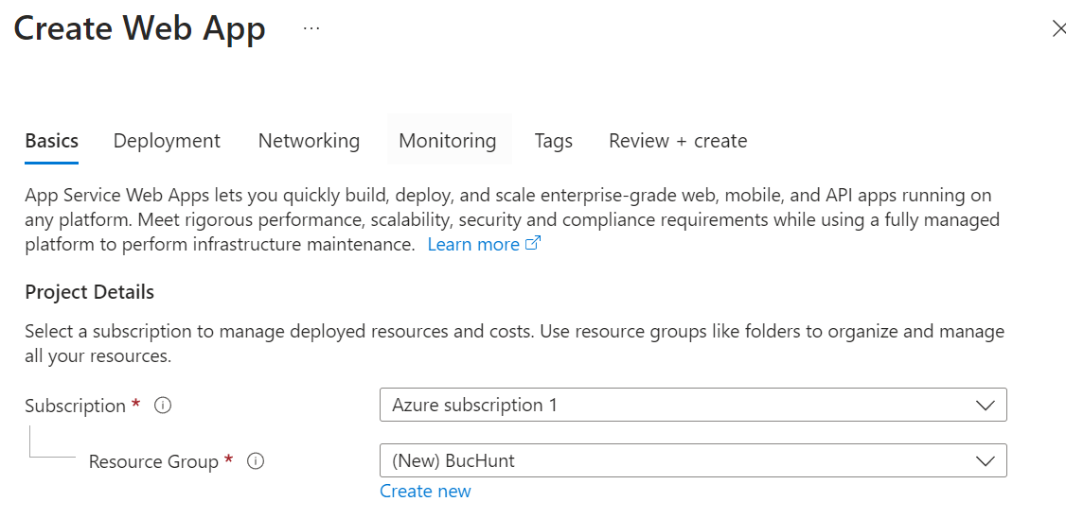

* 1. Hit the “Create New” Button.

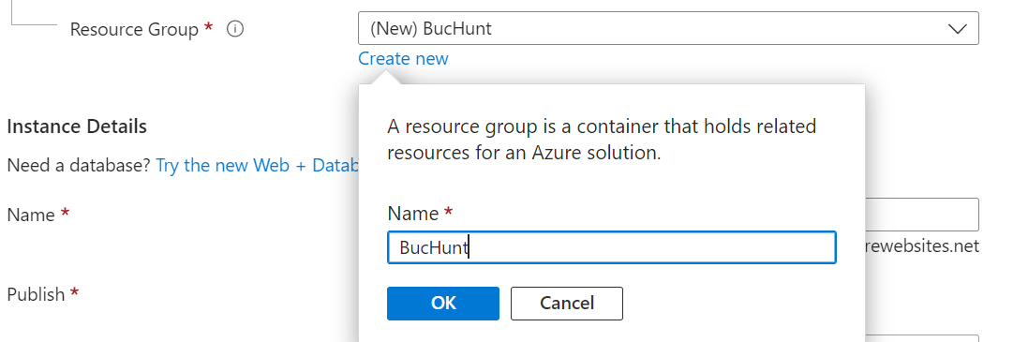

* 1. Name it “BucHunt”, then hit “OK”.

1. Name the instance “BucHunt”. Since we, Team BOB, have taken the name “BucHunt”, you may have to rename it to BucHunt2, BucHunt3, etc.

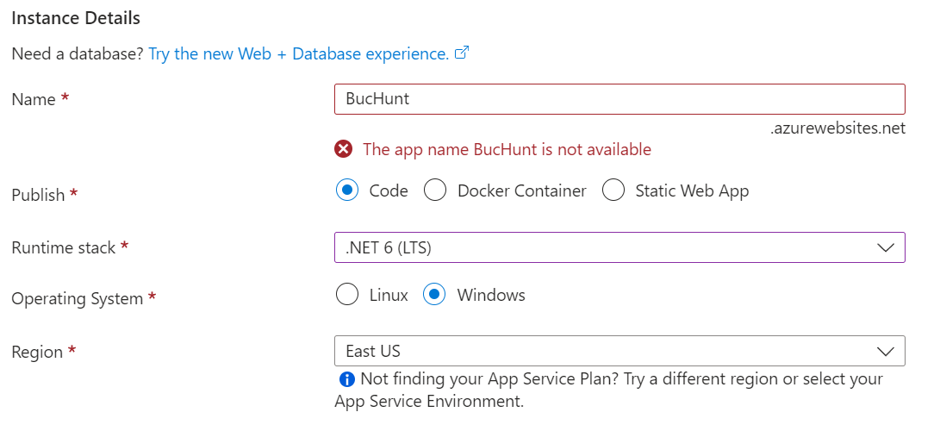

(See how BucHunt2 is not taken…)

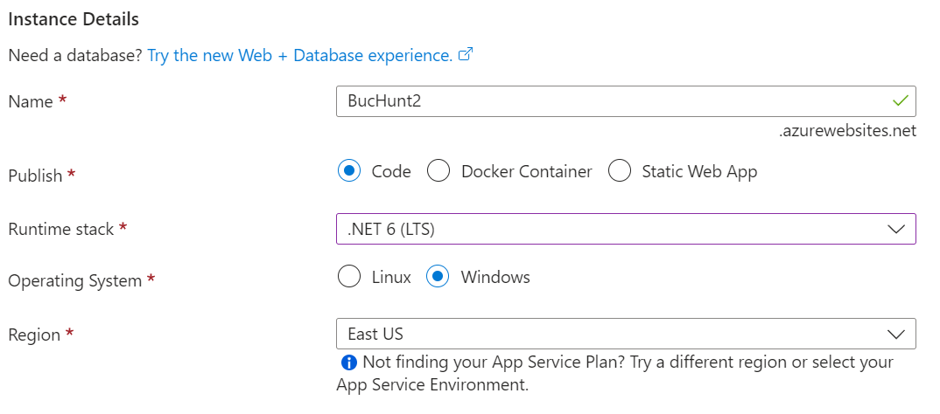

1. Change the Runtime Stack to .NET 6 (LTS).
2. Leave the pricing plans as is. It should look like this:

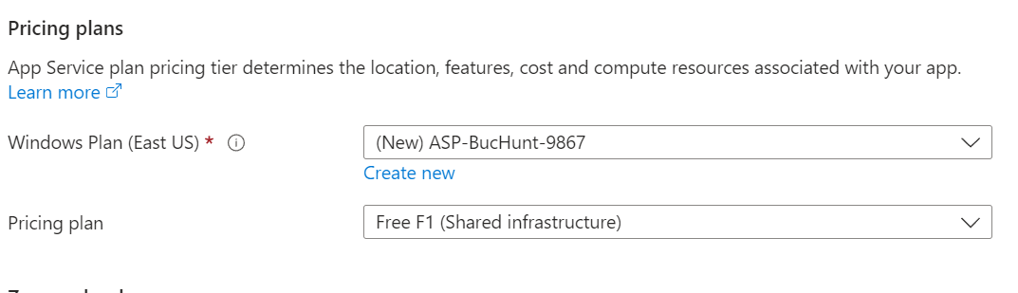

1. Hit Next: Deployment
2. Enable GitHub Actions for Continuous Deployment.

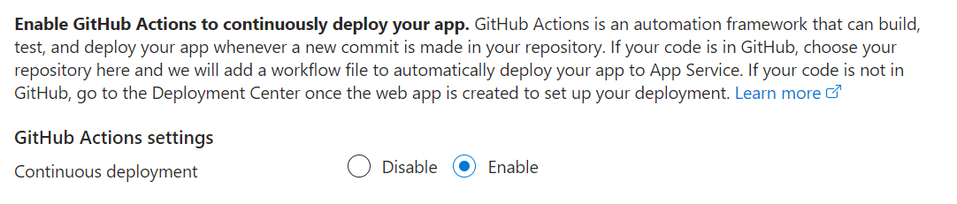

1. Hit “Authorize” under GitHub Action Details to connect your GitHub account.

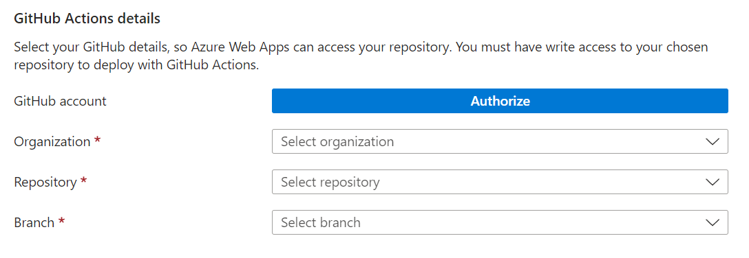



1. Choose your organization, your project repository, and the branch you plan to release on. The result should look similar to this:

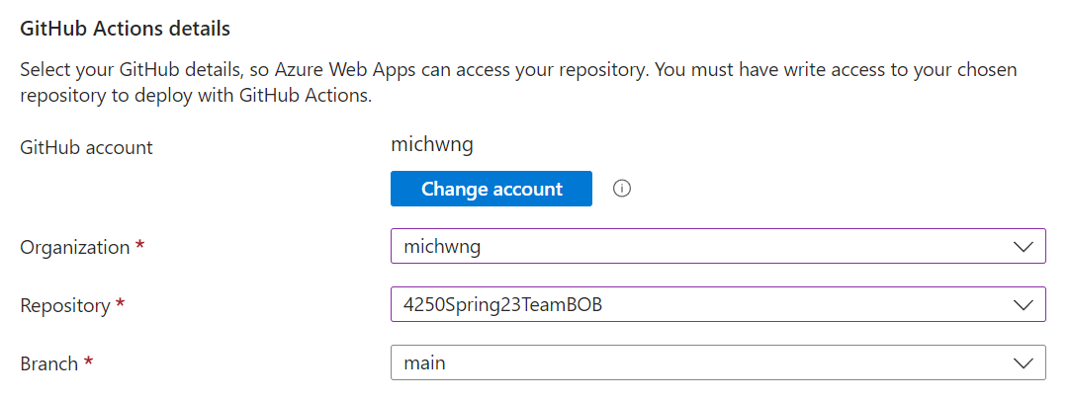

1. Hit the “Next: Networking” button at the bottom of the page.
2. Ensure that Public Access is On. (That way people can access your web app).

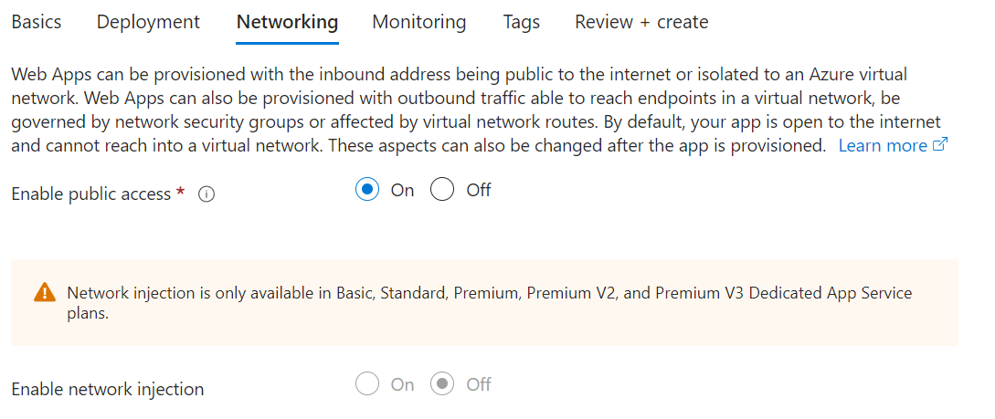

1. Hit the “Next: Monitoring” button at the bottom of the page.
2. Configure your application insights as needed. This is what my configuration looks like:

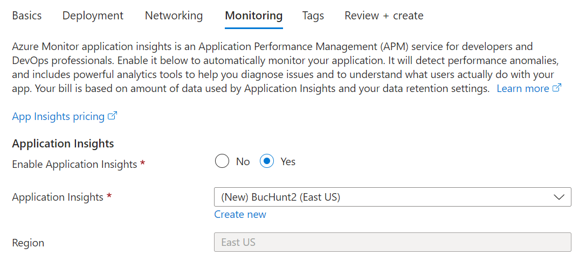

1. Hit the “Next: Tags” button.
2. No tags are necessary, but I added a Name tag in case.

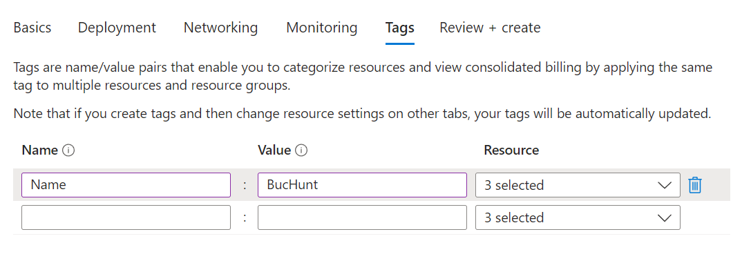

1. Hit the “Review + Create” button.
2. Review over your Web App Settings and hit “Create” when ready.
3. Wait for the Deployment to deploy.
4. You should see this screen once it’s done.

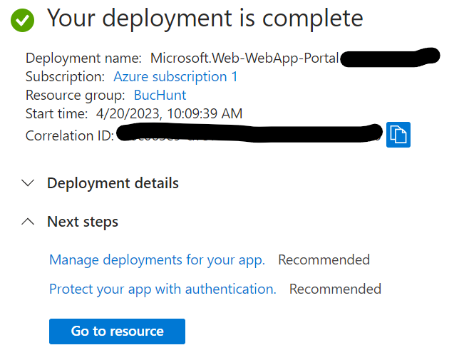



1. Hit “Go to resource”. You should see this screen.

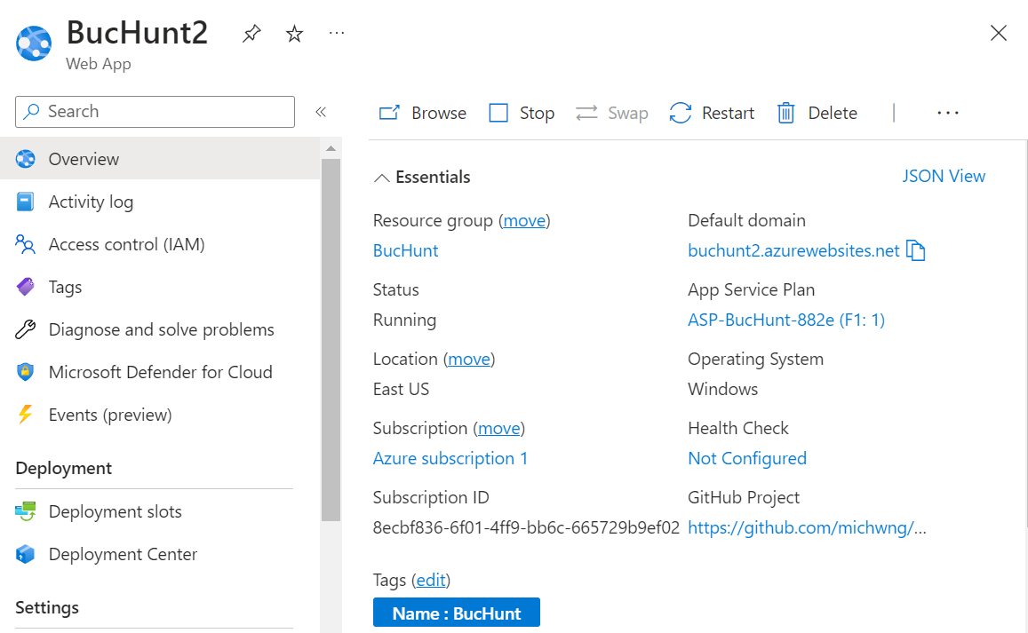



1. Note the Default Domain is **buchunt2.acurewebsites.net** (it will be different for you).
2. Try connecting to this website by clicking on the link.

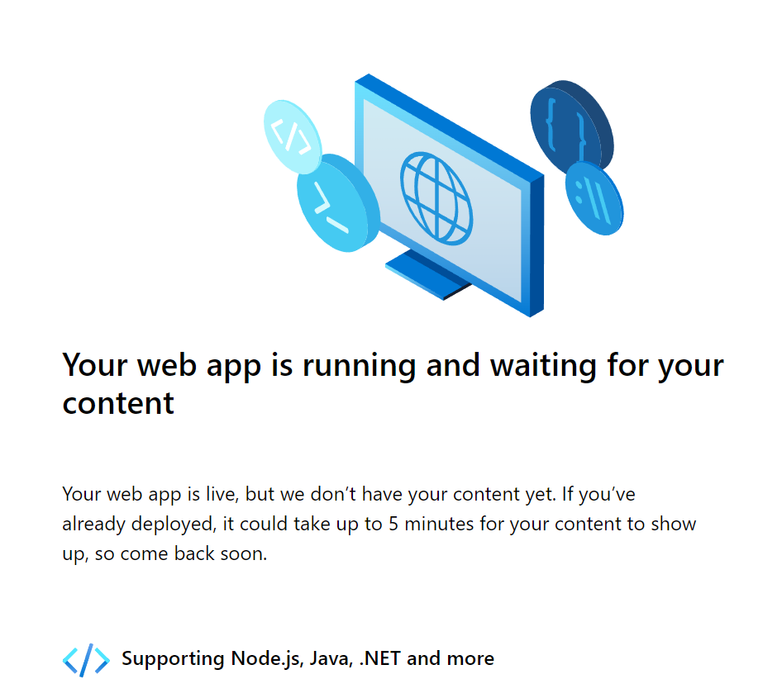

1. If you wait 5 minutes, nothing will happen. This is because you will need to publish the web app on Azure through Visual Studio, first.
2. Bring up your project on Visual Studio.
3. Go to Build > Publish ScavengeRUS.
4. Hit “New”

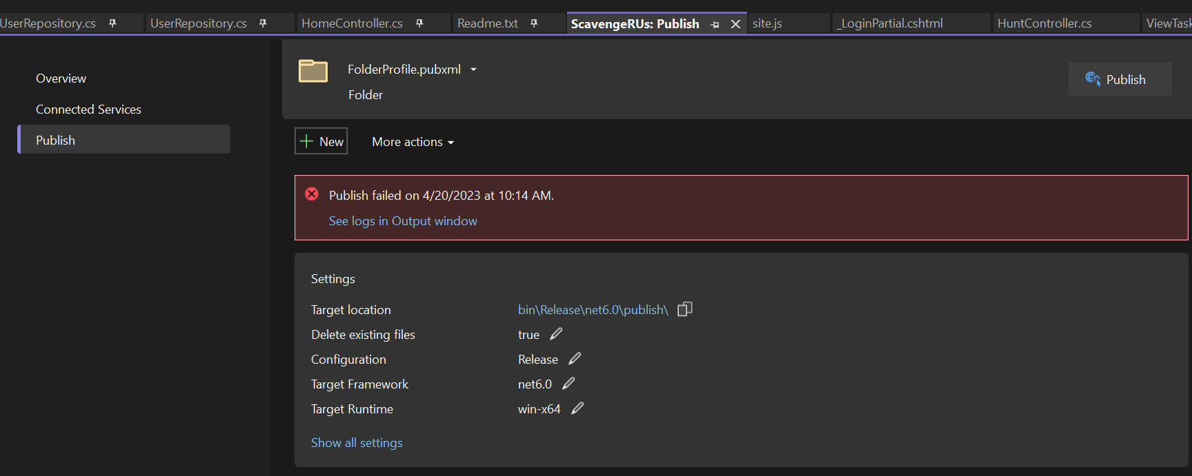



1. Publish to Azure.

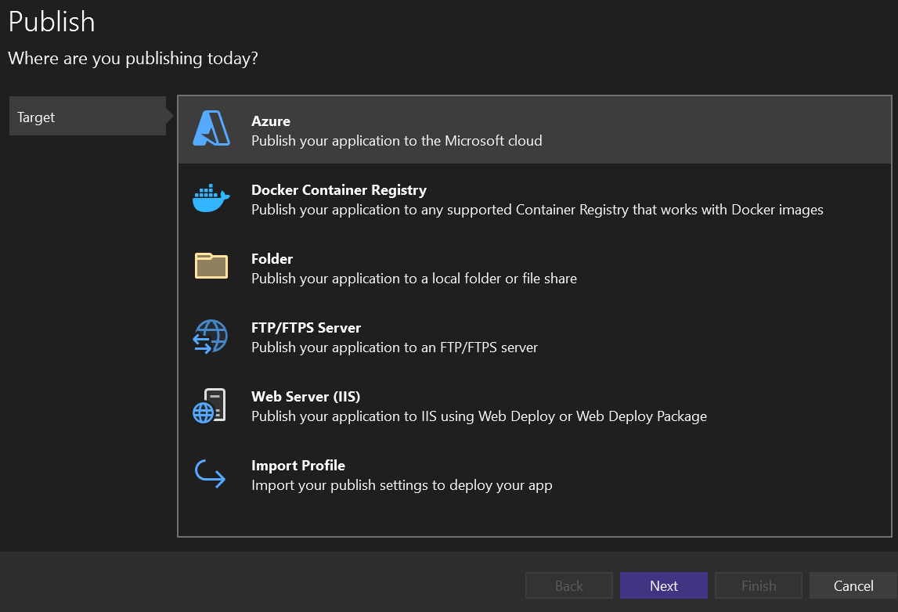



1. Set the Specific Target to Azure App Service (Windows)

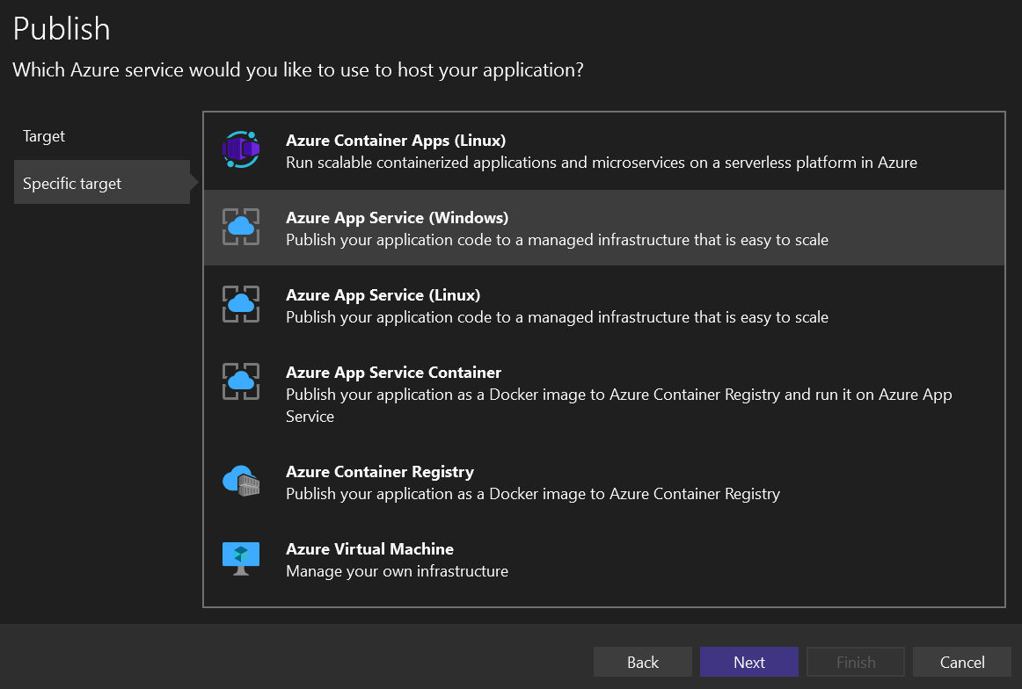



1. Sign into your Azure Account. You should see this screen once you sign in.

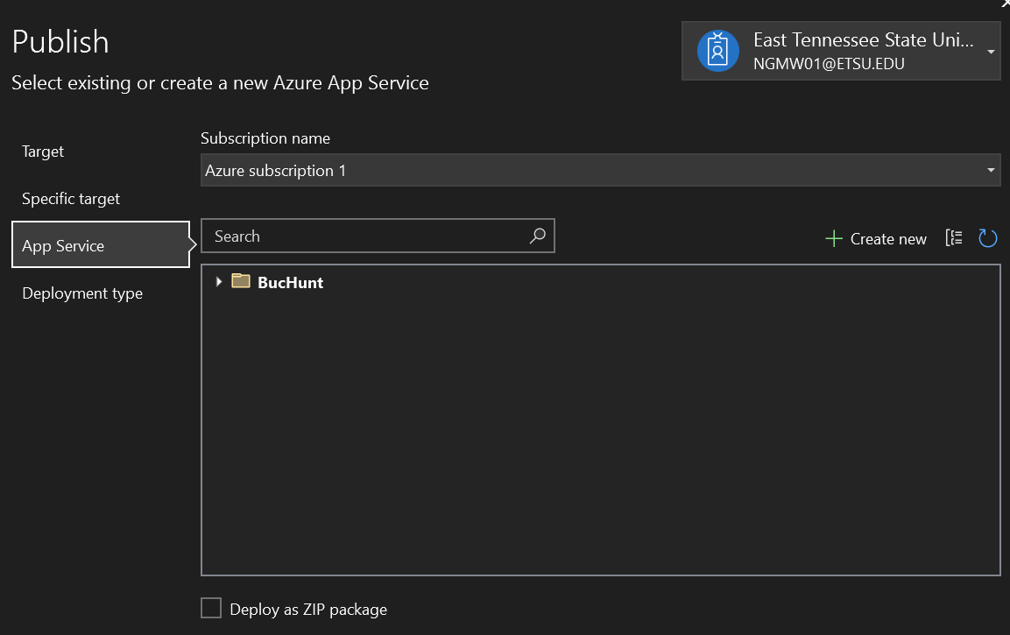

1. Ensure your subscription name is Azure Subscription 1 (this may be different, depending on how you configured your web app).
2. Select BucHunt2, then hit “Next”.

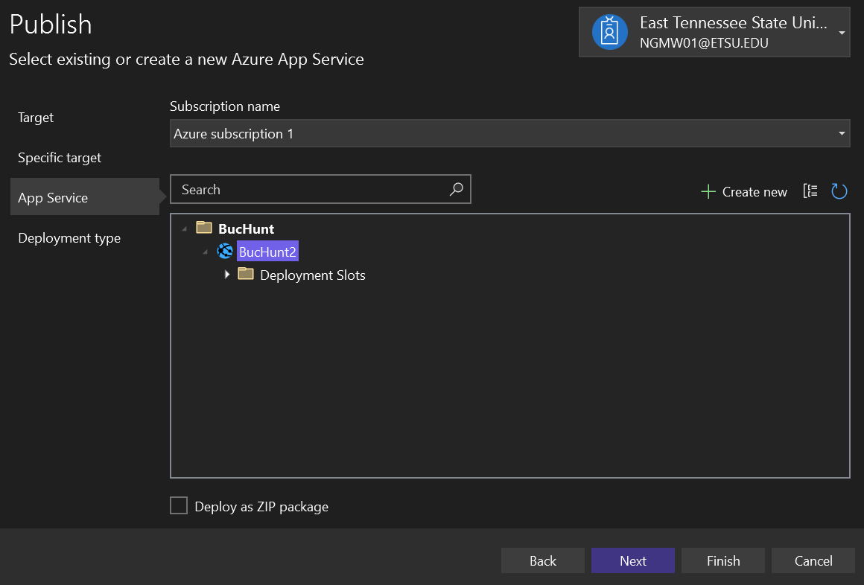

1. You have two options here:

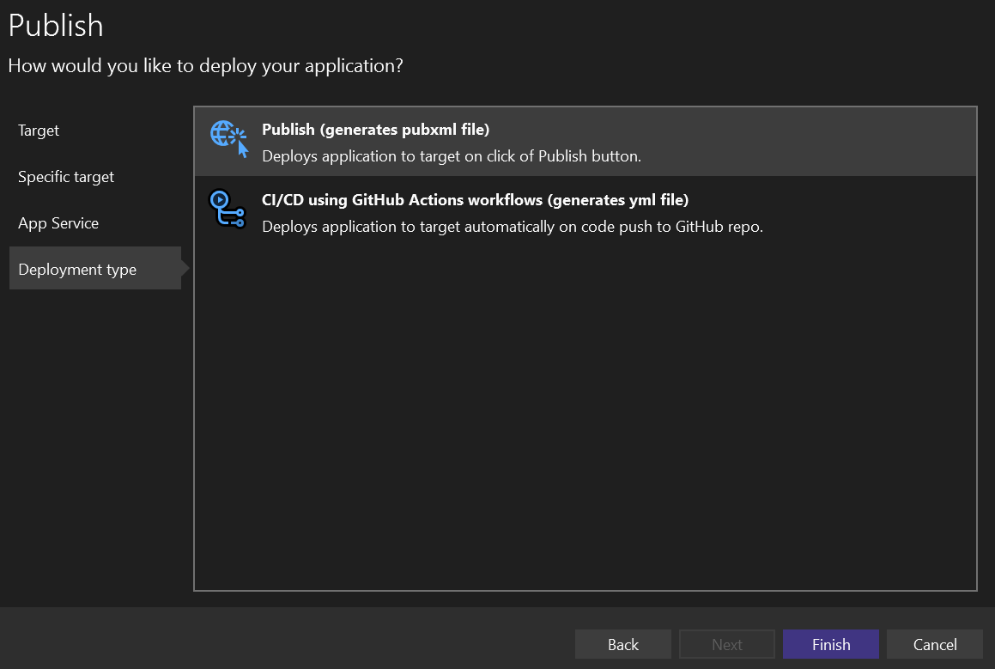

1. You can choose either, depending on what your team prefers. For my project. I chose Publish (generates pubxml file).
2. Hit “Finish”.
3. Publish your BucHunt Web Deployment. Hit that “Publish” Button.

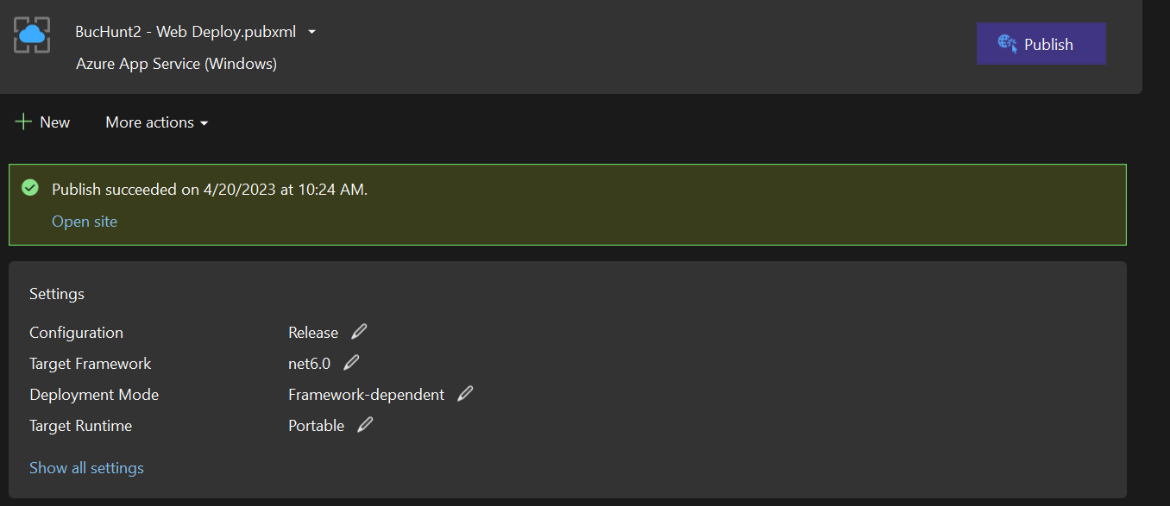

1. Once the application is done publishing, it should automatically pull up the website you just deployed.

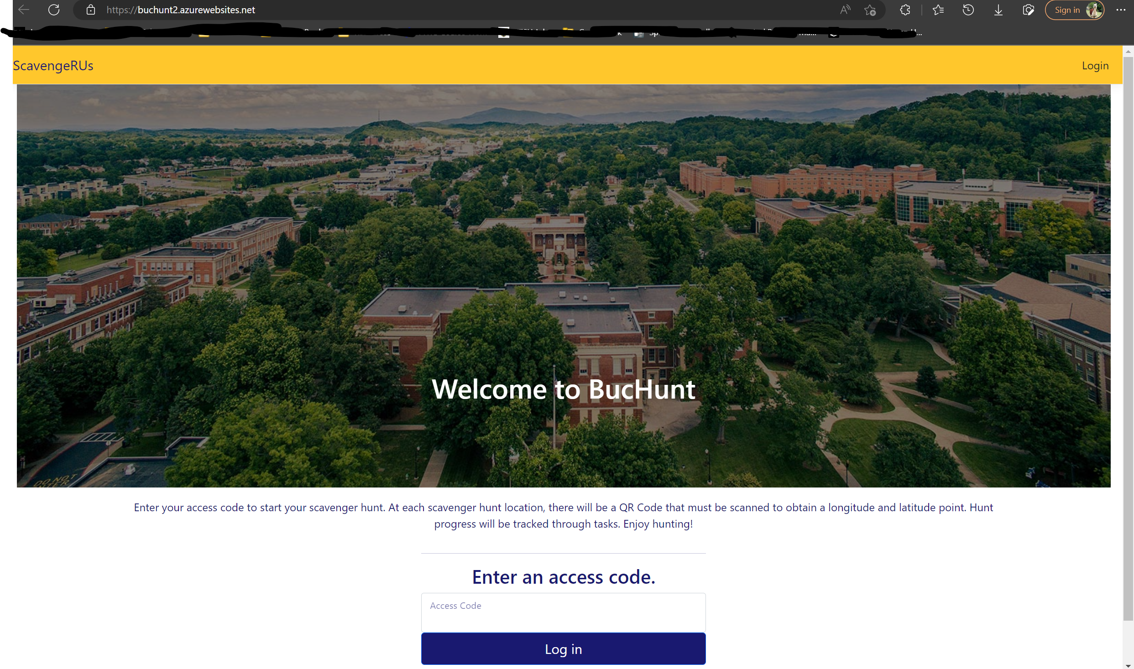

1. Copy and Paste the URL to Discord (or whatever tool you use to connect with your team). It should look like <https://buchunt2.azurewebsites.net/>.
2. Share the website with your team. You’re done!